**Project 1**



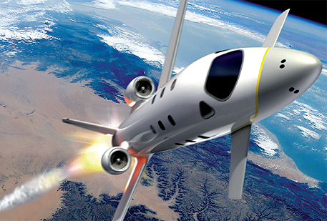

**FDIR**

*Spacecraft fault protection system*

**Euro Team**

|  |  |
| --- | --- |
| **Mikko AHVENNIEMI** | 20096680 |
| **Pierre ALAUZET** | 20096699 |
| **Julien COLIN** | 20096706 |
| **Benoît STARCK** | 20096705 |

**Table of contents**

October 15th, 2009

**CS554 - Design for Software & Systems**

**1.** **Problem understanding** 6

a. Business case & system context 6

**i.** **FDIR utility** 6

**ii.** **System requirements** 6

b. Problem frames 6

**i.** **Domains identification** 6

**ii.** **Context Diagram** 6

**iii.** **Problem frames** 6

**2.** **Functional requirements (use-case model)** 7

a. Use-case diagram 7

**i.** **Actors description** 7

**ii.** **Use-case diagram** 7

**iii.** **Use-case specifications** 7

b. Sequence diagrams 10

**i.** **Fault recovering** 10

**ii.** **Safing response in case of hazardous conditions** 10

**iii.** **Critical failure** 10

**3.** **Non-functional requirements** 11

a. Identified quality attributes 11

**i.** **Testability** 11

**ii.** **Availability** 11

b. Improvised quality attributes 11

**i.** **Reliability** 11

**ii.** **Resilience** 11

**iii.** **Response time** 11

**4.** **Usability analysis & design** 12

a. Preliminary user interface design 12

b. Discussion on usability scenarios 12

Illustration table

Figure 1: Use case diagram 6

**Introduction**

1. **Problem understanding**
   1. Business case & system context
      1. FDIR utility
      2. System requirements
   2. Problem frames
      1. Domains identification
      2. Context Diagram
      3. Problem frames
2. **Functional requirements (use-case model)**
   1. Use-case diagram
      1. Actors description
      2. Use-case diagram

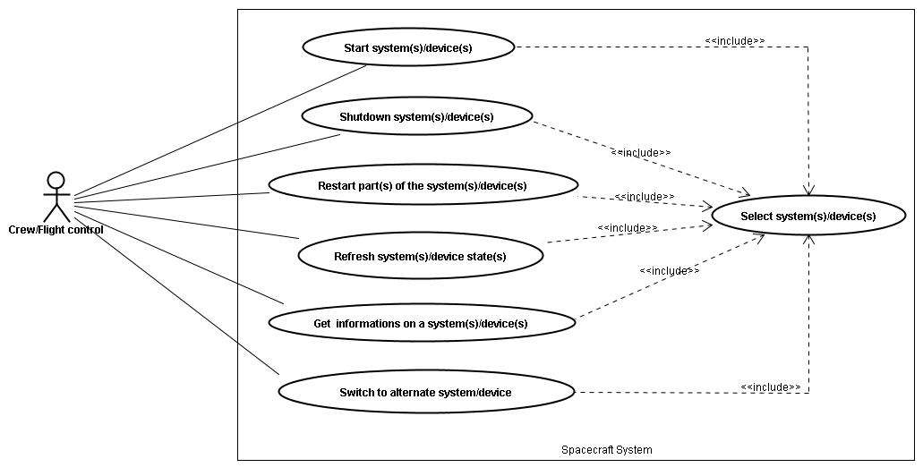

Figure 1: Use case diagram

* + 1. Use-case specifications

|  |  |
| --- | --- |
| Name | Start system(s)/device(s) |
| Actors | Crew / Flight control |
| Description | User can start device(s) or system(s) of the spacecraft system whenever he wants or because it was shutdown |
| Precondition | - System(s) are off  - One or several device(s) or system(s) have been selected  - Selected device(s) or system(s) must not be dependant on other device(s) or system(s) that are offline. |
| Events flow | 1. Click on the “start” button  2. Wait for the system to start |
| Post-condition | System(s) has been started |
| Exception | * System states could be already turned on while it is still displayed as “off” on the FDIR system * System cannot be started because it’s broken. Display on error message. * If selected device(s) or system(s) are dependant on other device(s) or system(s), display a warning and information about the dependencies, and offer to override. |

|  |  |
| --- | --- |
| Name | Shutdown system(s)/device(s) |
| Actors | Crew / Flight control |
| Description | User can shutdown device(s) or a part(s) of the spacecraft system whenever he wants or in case of failure |
| Precondition | - Devices or parts of the system have to be running  - One or several device(s) or system(s) have been selected  - Other systems must not have dependencies to the selected device(s) or system(s) |
| Events flow | 1. Click on the “shutdown” button |
| Post-condition | System(s) has been shutdown |
| Exception | * System states could be already turned off while it is still displayed as “running” on the FDIR system * If other systems have dependencies to the selected devices(s) or system(s) display a warning and information about the dependencies and offer to override. |

|  |  |
| --- | --- |
| Name | Restart part(s) of the system(s)/device(s) |
| Actors | Crew / Flight control |
| Description | User can restart a device or a part of the spacecraft system whenever he wants or in case of failure |
| Precondition | - Device or part of the system has to be running  - Requested system(s)/device(s) have been selected  - Other systems must not have dependencies to the selected device(s) or system(s) |
| Events flow | 1. Click on the “restart” button |
| Post-condition | System is restarting |
| Exception | * System states could be already turned off while it is still displayed as “running” on the FDIR system * If other systems have dependencies to the selected devices(s) or system(s) display a warning and information about the dependencies and offer to override. |

|  |  |
| --- | --- |
| Name | Refresh system(s)/device(s) states |
| Actors | Crew / Flight control |
| Description | User can refresh the states of any device or system to see if this one is still working correctly or not |
| Precondition | - Device or part of the system has to be running  - Requested system(s)/device(s) have been selected |
| Events flow | 1. Click on the “refresh” button |
| Post-condition | System is refreshing |
| Exception | - If the system(s) or device(s) are not responding change status not responding. |

|  |  |
| --- | --- |
| Name | Switch to alternate system/device |
| Actors | Crew / Flight control |
| Description | If the device is not responding or if there is a failure, user may switch to another system/device |
| Precondition | - Select **one and only one** system or device  - Requested part has been selected  - Other system(s) or device(s) must not have dependencies to the selected system, or the switch has to be able to be done seamlessly. |
| Events flow | 1. Click on the “switch” button |
| Post-condition | Alternate system takes the control. |
| Exception | * If the alternate system is broken as well, it may generate a fatal error of the system * If other system(s) or device(s) have dependencies to the selected systems and the switch cannot be made seamlessly, display a warning and information about the dependencies, and offer to override. |

|  |  |
| --- | --- |
| Name | Get information on a system(s)/device(s) |
| Actors | Crew / Flight control |
| Description | User may seek information about any device or system on the spacecraft |
| Precondition | - Requested system(s)/device(s) have been selected |
| Events flow | 1. Specify query  2. Click on the “GetInfo” button |
| Post-condition | Information about the selected system appears on the screen. |
| Exception |  |

|  |  |
| --- | --- |
| Name | Select system(s)/device(s) |
| Actors | Crew / Flight control |
| Description | User can select any system or device in order to issue commands |
| Precondition |  |
| Events flow | 1. Select the requested part(s) |
| Post-condition | The chosen part is selected. |
| Exception | The chosen part is still not selected. |

* 1. Sequence diagrams
     1. Fault recovering
     2. Safe response in case of hazardous conditions
     3. Critical failure

1. **Non-functional requirements**
   1. Identified quality attributes
      1. Testability
      2. Availability
   2. Improvised quality attributes
      1. Avaibility
      2. Reliability
      3. Resilience
      4. Response time
2. **Usability analysis & design**
3. Preliminary user interface design

Displaying information continuously 🡪 multiple screens but no tabs

Overview of the spacecraft always available 🡪 list of systems & subsystems with information (monitoring values, temperature, pressure)

Professional interface 🡪 non useful features like displaying spacecraft screens. Crew would be formed to be on the spacecraft and do not need to have a visualization of the spacecraft. Title of device or system is enough

Locate the fault 🡪 displaying left panel with spacecraft scheme. List of the systems appearing on the tree should appears on the scheme too. If an alert appears on one system, we should be able to localize it geographically on the scheme.

Keep the control of the spacecraft with safety, observability & commandability 🡪 bottom panel with buttons (shutdown, restart, backup and recovery data)

1. Discussion on usability scenarios

**Conclusion**

References

**Web Sites**

**Articles**

**Books**